**Branch ID:**

1. There are total 47 branches
2. Each branch mostly covers single state and very few covers multiple states.
3. Top revenue generating branches are 20, 7, 1 and 17 (above $80k in three years) and 37 branches with revenue > $50K – 3years cumulative.

|  |  |  |  |
| --- | --- | --- | --- |
| Row Labels | Count of State | Sum of Sum of Ticket Revenue | Sum of Count of Ticket Number |
| B0001 | 6 | 92360.03 | 247 |
| 2011 | 2 | 25692.82 | 77 |
| 2012 | 2 | 33458.1 | 90 |
| 2013 | 2 | 33209.11 | 80 |
| B0007 | 9 | 118316.94 | 257 |
| 2011 | 3 | 24507.8 | 65 |
| 2012 | 3 | 38438.68 | 88 |
| 2013 | 3 | 55370.46 | 104 |
| B0017 | 3 | 88243.76 | 171 |
| 2011 | 1 | 15242.35 | 46 |
| 2012 | 1 | 24960.1 | 50 |
| 2013 | 1 | 48041.31 | 75 |
| B0020 | 3 | 127820.77 | 252 |
| 2011 | 1 | 41672.55 | 75 |
| 2012 | 1 | 38749.97 | 87 |
| 2013 | 1 | 47398.25 | 90 |
| B0029 | 3 | 72656.66 | 164 |
| 2011 | 1 | 20475.99 | 37 |
| 2012 | 1 | 24442.17 | 70 |
| 2013 | 1 | 27738.5 | 57 |
| Grand Total | **24** | **499398.16** | **1091** |

Table: Top 5 branches with their details over years

**Customer ID:**

1. There are total 1058 unique customers with an avg. no. of calls 5 and spending of $2000 and in 3 years.
2. Returning/base customers who used services all 3 years are (357/1058) i.e. 33.74% and contribute 30% of total revenue.
3. On an avg. 250 no. of service calls made by new customers every year
4. Lost customers who did not show after 2012 85/1058 i.e. 8%

Figure: Total Calls Month-wise 2011

Figure: Total Calls Month-wise 2012

:

Figure: Total Calls Month-wise 2013

**Customer Type:**

1. There are total 3 types
2. Major contribution (revenue plus service call wise) is by Customer Type 1

|  |  |  |  |  |
| --- | --- | --- | --- | --- |
| Customer Type | % of Base Customers | Avg. Spend | % Of Calls made | No. of Customers |
| Type 1 | 36.81 | 418.50 | **56.79** | **600** |
| Type 2 | 39.78 | 473.07 | 14.21 | 151 |
| Type 3 | 24.67 | 500.50 | 28.99 | 307 |

Table: Customer type spread

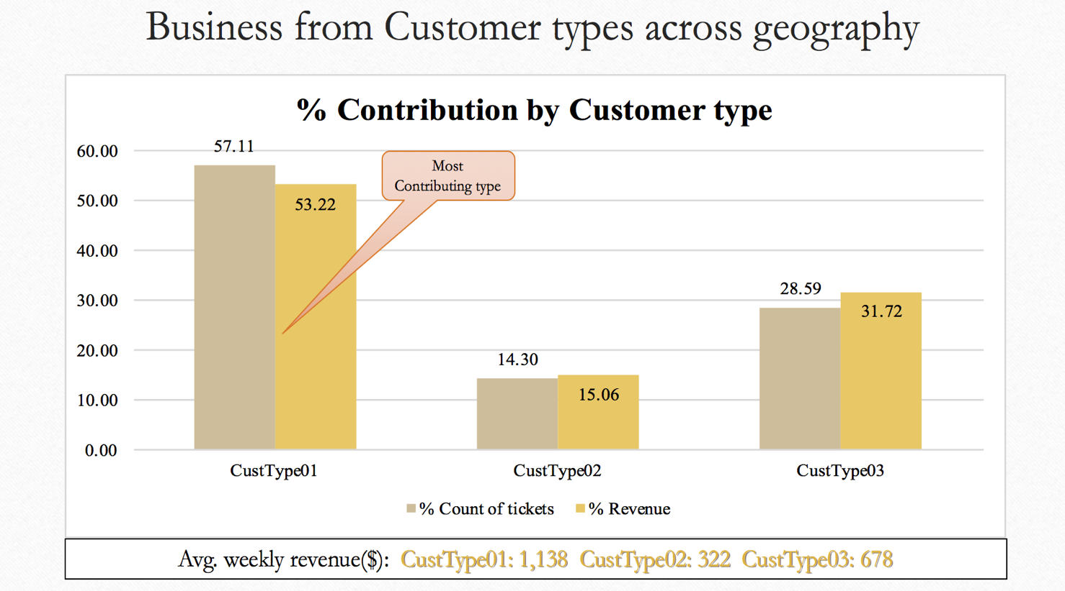

Figure: Business from Customer Type across geography

**Job Code:**

1. There 34 different job codes used across branches
2. Most commonly used codes are as below with greater than 50K revenue.

|  |  |  |
| --- | --- | --- |
| Job Code | Count of Ticket Number | Sum of Ticket Revenue |
| 2 | 631 | 370439.56 |
| 1 | 872 | 322487.37 |
| 0 | 391 | 260756.11 |
| 5 | 622 | 152724.67 |
| 9 | 244 | 141072.03 |
| 13 | 164 | 125651.17 |
| 4 | 300 | 99793.90 |
| 25 | 310 | 99225.37 |
| 29 | 271 | 81517.30 |
| 18 | 45 | 70330.66 |
| 30 | 118 | 60261.26 |
| 8 | 58 | 59455.28 |
| 14 | 90 | 54216.57 |
| 23 | 114 | 54187.72 |
| Grand Total | 4230 | 1952118.97 |

Table: Top Job codes with Revenue greater than $50K

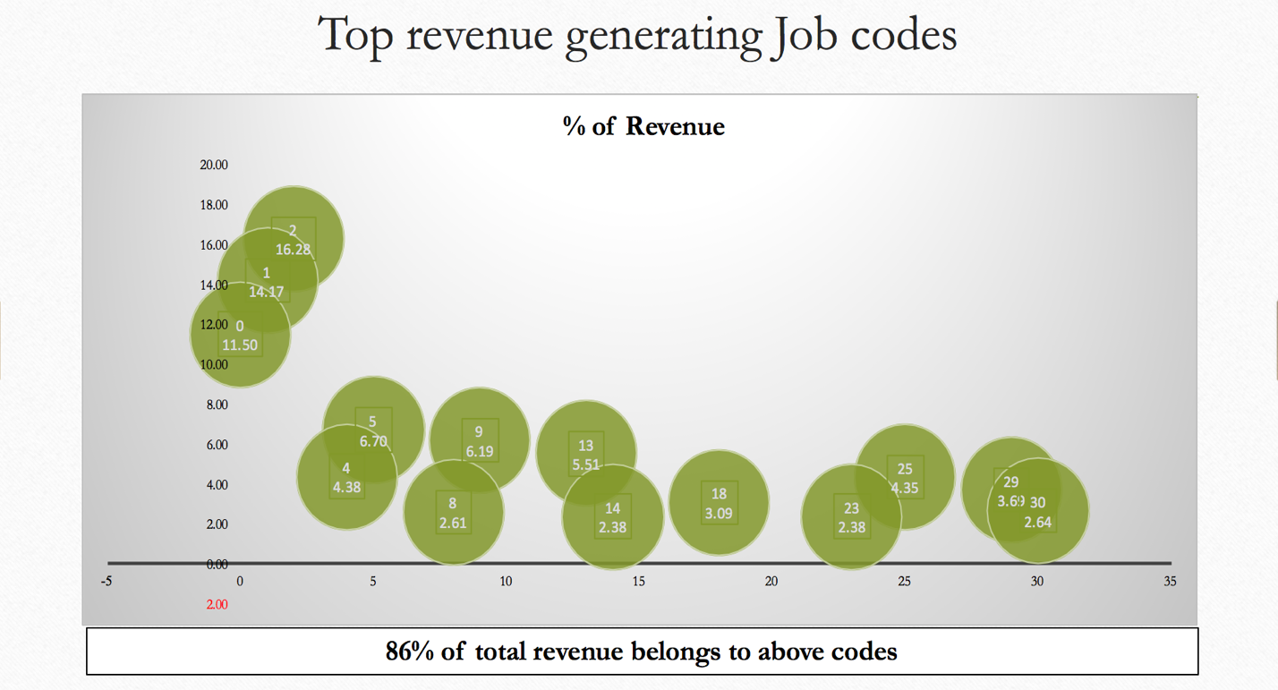

Figure: Top Revenue Generating Job codes

**Ticket Revenue:**

This column helps understand revenue generated from each individual ticket in conjunction with branch, customer type and job code.

C**all date, schedule date, dispatch date and complete date:**

These columns help prepare analysis of trend, seasonality, yearly, monthly and day of week, etc. for each branch, Customer type and job code

**Call time, schedule time, dispatch time and complete time:**

These columns help understand and derive Time of Day analysis, avg. service time for jobs across branches, also disgruntled customers

**State/City:**

Gives geographical information of customer and will contribute in branch/state level analysis

Churn:

Customer who did not show in last 6months are flagged as lost/churned customers. Based on this we defined Churn variable for our training and test data.

**Trend and seasonality Study Jan 2011 till Dec 2013 for service calls:**

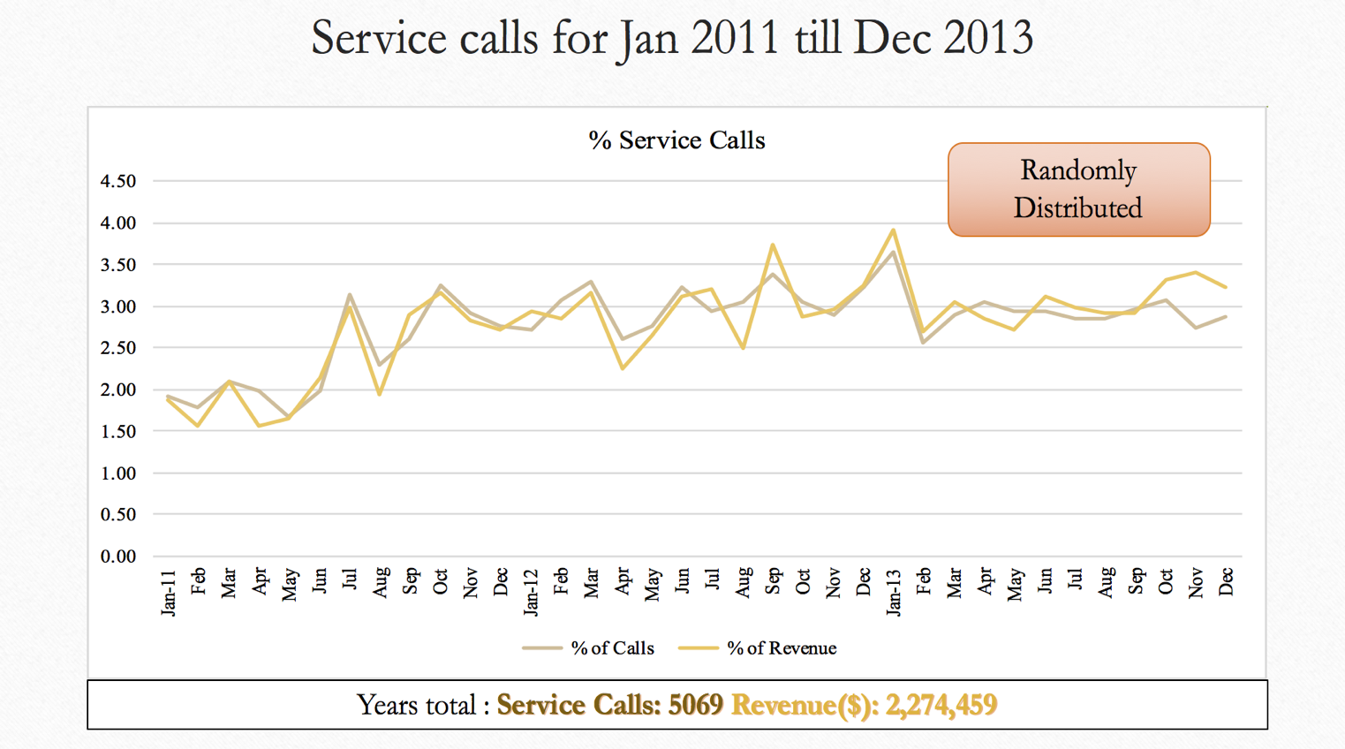

Figure: Service calls from Jan 2011 to Dec 2013 on scale of % #of Calls and % of Revenue

**Day of week analysis:**

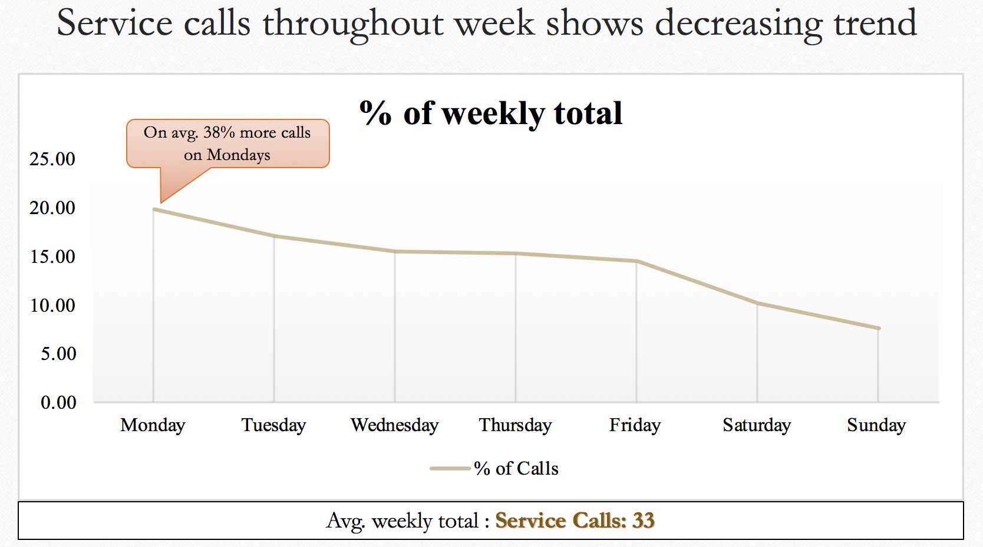

Figure: Service call throughout week

**Hour of Day Analysis:**

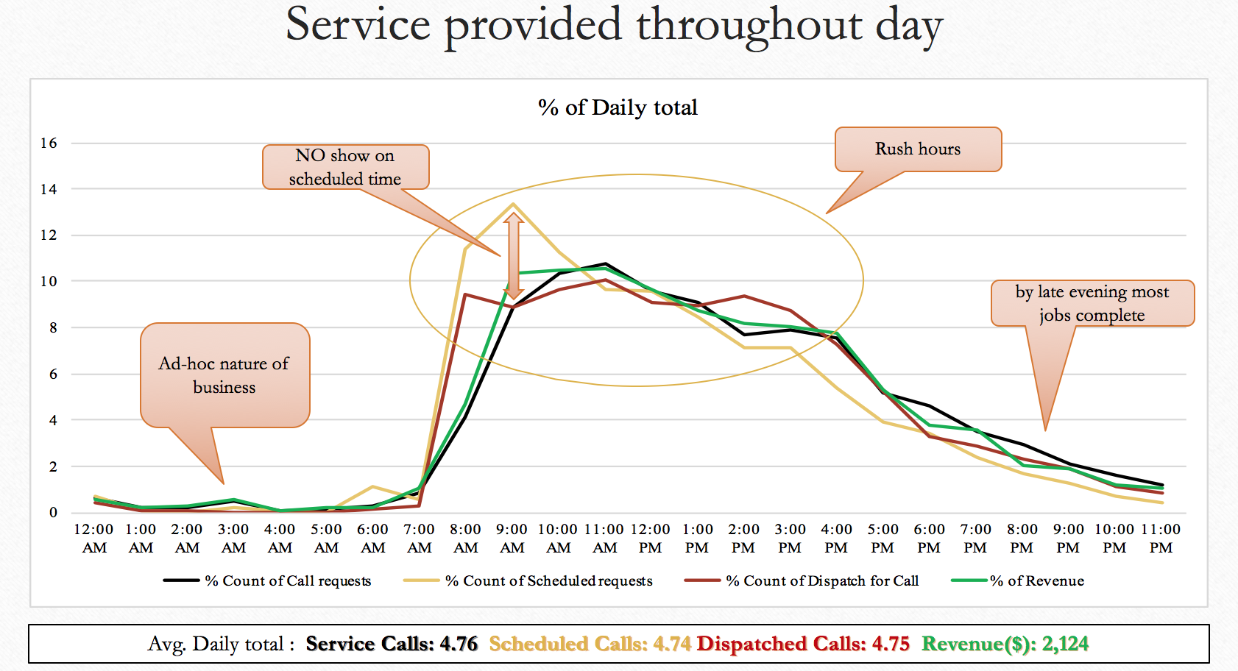

Figure: Service call throughout Day

**Sales drilled down per Transaction level:**

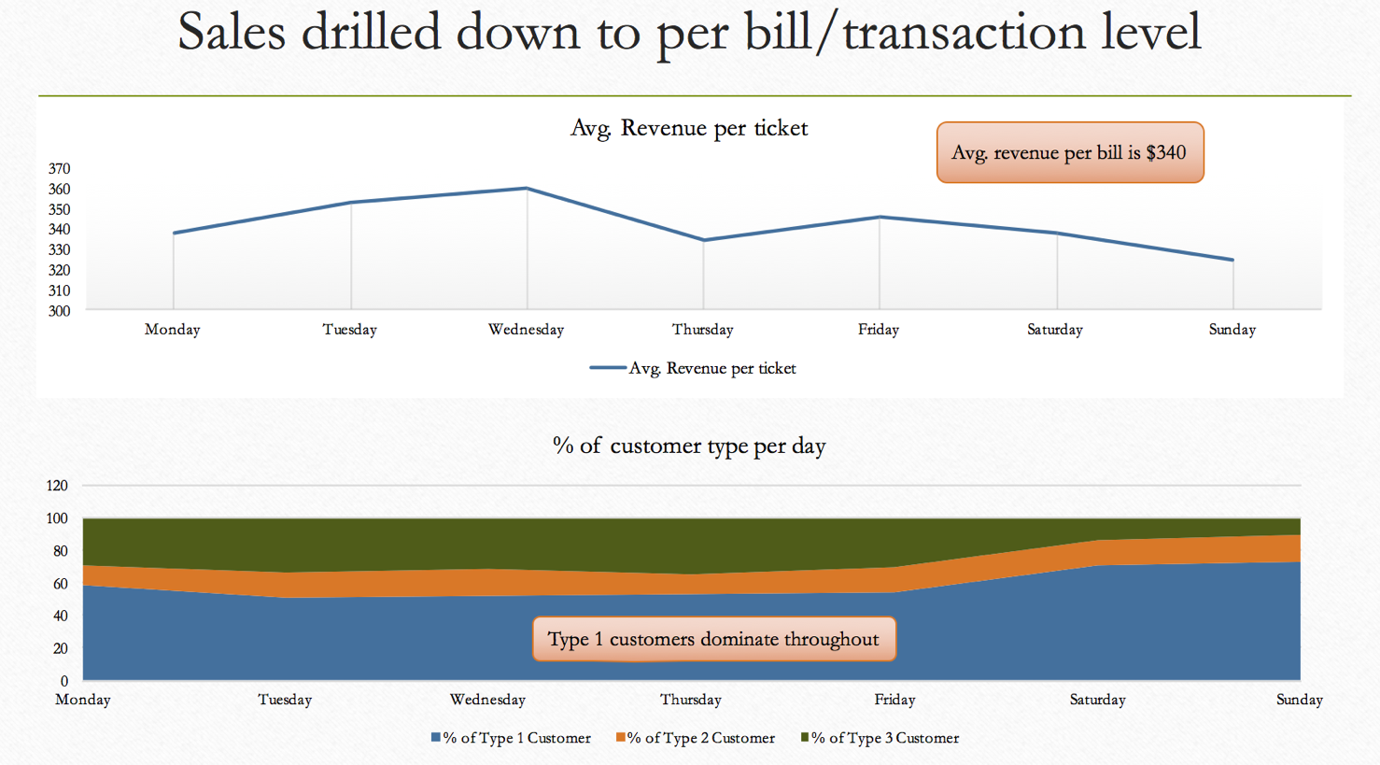

**Univariate Analysis vs Churn:**

